Exercise 2 : Implementation of Factory Method Pattern

Logic and Implementation Code For Factory Method Pattern :
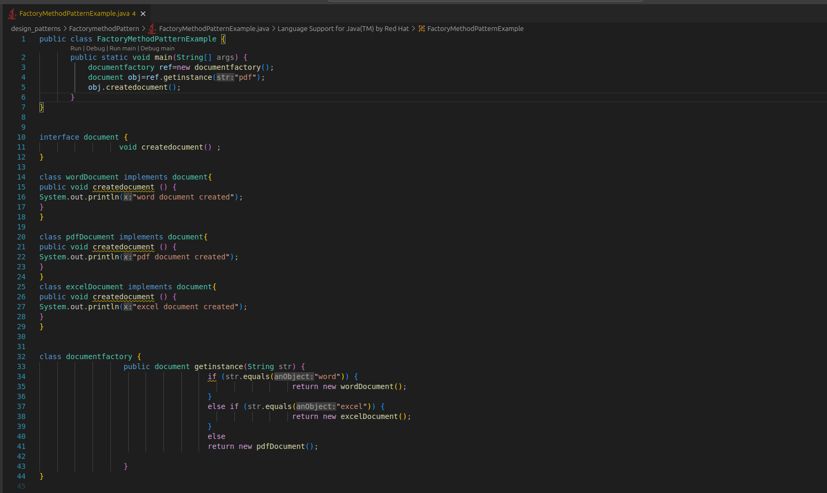
Output :

